SugarCube Scanner

Modeller User Experience Design Document

vA.0.1

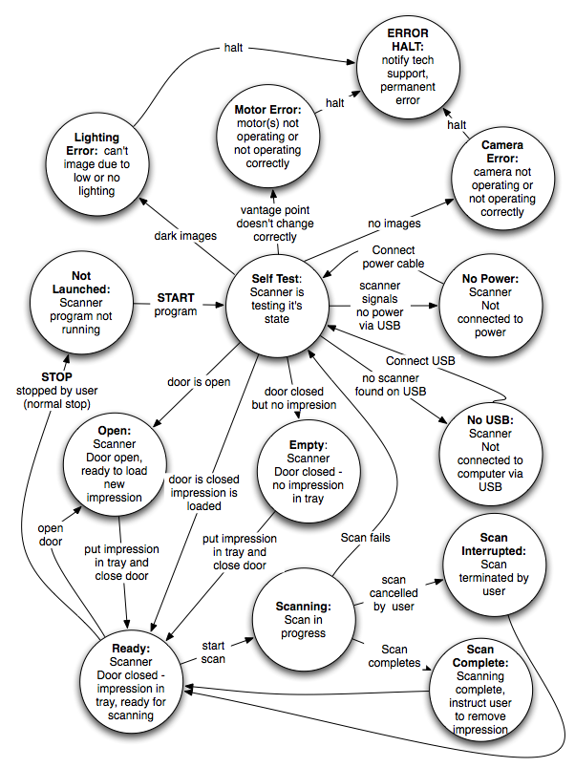
April 21, 2013

Scott McGregor
User Experience Designer

SoundFit, LLC

Revision History

Date | Description | Author | Comments
04/21/2013 | <Version 1> | Scott McGregor | <First Revision>

Document Approval

The following User Experience Design Document has been accepted and approved by the following:
Signature | Printed Name | Title | Date
 | Scott McGregor | User Experience Designer

Table of Contents

1. Introduction 4

1.1 Context of Use and Terminology 4

1.2 Scope 4

Design Notes: 4

1.5 Overview 4

2. General Description 4

2.1 Product Perspective 4

2.2 Product Functionality and Design Goals 4

2.3 User and Scanner states 4

2.4 General Constraints 4

2.5 Assumptions and Dependencies 4

3. Specific Requirements 4

3.1 External Interface Requirements 4

3.1.1 User Interfaces 4

3.1.2 Hardware Interfaces 4

3.1.3 Software Interfaces 4

3.1.4 Communications Interfaces 4

3.2 Functional Requirements 4

3.2.1 <Functional Requirement or Feature #1> 4

3.2.2 <Functional Requirement or Feature #2> 4

3.3 Use Cases 4

3.3.1 Use Case #1 4

3.3.2 Use Case #2 4

3.4 Classes / Objects 4

3.4.1 <Class / Object #1> 4

3.4.2 <Class / Object #2> 4

3.5 Non-Functional Requirements 4

3.5.1 Performance 4

3.5.2 Reliability 4

3.5.3 Availability 4

3.5.4 Security 4

3.5.5 Maintainability 4

3.5.6 Portability 4

3.6 Inverse Requirements 4

3.7 Design Constraints 4

3.8 Logical Database Requirements 4

3.9 Other Requirements 4

4. Analysis Models 4

4.1 Sequence Diagrams 4

4.3 Data Flow Diagrams (DFD) 4

4.2 State-Transition Diagrams (STD) 4

5. Change Management Process 4

A. Appendices 4

A.1 Appendix 1 4

A.2 Appendix 2 4

1. Introduction
The SugarCube(TM) Scanner from SoundFit is intended to enable an audiologist, or staff member in an audiologist office to scan physical ear impressions and transmit their 3D geometries to a distant Audiology Laboratory who will receive that 3D geometry, and produce custom fit eartips for hearing aids, communications devices, hearing protection, or swim plugs, instead of shipping the physical impressions as they currently do.

For this alpha release we will only support sending impressions to our alpha test partner lab, Pacific Coast Laboratories (PCL), although we envision the ability to send models to other audiology laboratories, hearing aid, communications and other eartip manufacturers in a future release.

This document is a supplement to the Earchives GUI mockup accessible through the index page at http://sc6921.wix.com/sugarcube - !modeler/c6xu. Both this document and the GUI are living documents, expected to change throughout the alpha and beta programs. Where there are versioning differences between the two, the online demo shall be presumed to be the more accurate.

1.1 Context of Use and Terminology
This section describes the context in which our service is used, including the affected stakeholders (of which the users are a subset), real and virtual objects handled or transmitted, and software and systems that do the processing. Here we also define the terminology we will use throughout this document to describe those components in the context

For this service to achieve this objective, there will be two “users” of two different pieces of software:

“Scanner user” The audiologist or their staff member who operates the scanner software.

“Modeler” The laboratory staff member who receives a 3D model using the model capture software and prepares an eartip model for manufacturing using CAD eartip modeling software. For the purposes of this release we plan support only Secret Ear Designer(TM) from Cyfex as modeling software.

The modeler software, including the Earchives user interface, is all written by SoundFit, and will be described in the first version of this document.

The modeler primarily interfaces with our online database system that we refer to as our Earchives system. Modelers use this system to access orders and scans sent by Scanner Users, to store and retrieve various 3D Models associated with the scans and orders, to change status of orders and scans, and to trigger notifications to interested parties when an order or scan status changes. This Earchive system will all be written by SoundFit, though it involves processes that may run models through on line services run by other companies. In particular, for the foreseeable future we anticipate using Autodesk’s 123D Catch service to convert the images captured by our scanners into 3D Models. We may also rely on other open source or royalty free software for adjusting the scale of the 3D Models, for cropping away parts other than the impression, and for converting OBJ files created by 123D Catch into STL files required for CAD modeling (by tools like Secret Ear Designer (SED)) or for 3D Printing.

In our planned product release the scaling, cropping and converting steps will all be automatic, however, in our Alpha and Beta tests, we may require the Modeler to perform these steps using the NetFabb program. To facilitate this manual work, we have a design that enables the Modeler to download intermediate files, and upload the result files.

Using this scanner takes place in a larger context, shown in Figure 1, the Context Diagram.
As can be seen from the figure, in addition to the scanner user and modeler, there will typically be an “audiologist” (or audiological technician) who takes the physical impression, and the “patient”, who will ultimately wear the eartips, manufactured by audiology lab (“manufacturer”). In some cases the audiologist and scanner user will be the same person, and in most cases the modeler is an employee of the manufacturer and may sometimes be the same person.

In addition to the physical ear impressions, and the finished eartips delivered to the patient, our context diagram shows two 3D models.

The first 3D model is the 3D ear impression model that we get from converting 2D images captured by the scanner into a 3D model produced using a photogrammetry cloud server (in our current version using 123D Catch). This ear impression model is used as input to a CAD program (Secret Ear Designer in our current version) which produces as output a final 3D eartip model that can be sent to a 3D printer for manufacturing the finished eartips, either directly or by creating a casting mold.

There will be one impression model corresponding to the impressions taken, as captured by the scanning process. But there can be many eartip models, since different devices that the eartip must adapt may require different CAD models.

SoundFit owns responsibility for delivering to the Modeler an impression model that is ready for CAD processing or printing. But the performance of the CAD work is up to the manufacturer. In our Alpha and Beta tests there will be only one manufacturer, PCL, and they will use the Secret Ear Designer (SED) software exclusively for creating earpiece models.

SoundFit also allows the Modeler to attach any earpiece models created to our scan record in our Earchives for later use – but we do not require them to do so. SoundFit also allows the Modeler to update the order and scan status after we deliver the order and scan to the manufacturer. The Modeler can therefore signal to a scanner user that not only has their order been received, but the requested earpiece has been manufactured, and shipped, and a tracking ID can be shared with the scanner user using the Manufacturer’s Notes field. But the manufacturer is not obligated to make use of this additional status maintenance capability.

The context diagram in Figure 1 shows the Patient, Audiologist, Scanner user, Manufacturer and Modeler. The step marked “modeling software (includes NetFabb)” is the step that will initially be manual, but will ultimately be automated, enabling the Modeler to receive a 3D model of the impression immediately ready for use by the CAD Software.

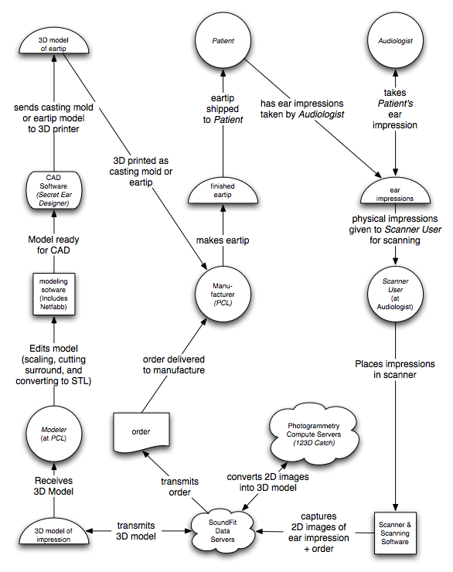
Figure 1: Context Diagram

1.2 Scope
There are envisioned to be multiple versions of this document and of the software, hardware and services described herein.

This initial version of this document is focused solely on the modeler user experience.

A related document describes the scanner user experience.

This document focuses primarily on the user interface by which the modeler will interact with data and applications on SoundFit’s server, with reference to programs running on the modeler’s computer (such as Autodesk 123D Catch, or NetFabb) which may be used only during the alpha or beta tests. This document also refers to but does not describe CAD programs such as Secret Ear Designer, or 3D printer programs that the Modeler may use, but which are outside the scope of what SoundFit provides and supports.

1.2.1 Design Notes:
Because there may be limitations that affect our design, which may be subject to change in the future, we may also include design notes that can alert readers to possible future areas of change. These are indicated by indented “sidebar” passages that look like this:

- In the initial design of the hardware, we expect the user to manually operate the drawer. A future design may allow the drawer to be opened or closed under programmatic control.

1.5 Overview
Section 2 of this document describes overall guiding principles, design goals and other considerations.

Section 3 contains specific GUI design specifications.

2. General Description
This section covers overall guiding principles. UI specifications are in section 3.

2.1 Product Perspective
A potential follow on to the ear impression scanner is an ear scanner. Since the end purpose of the ear impression scanner is identical to the purpose of the ear scanner - to rapidly transmit an ear geometry to the manufacturer, the Modeler user interface can and should be the same, allowing us to treat the impression scanner and ear scanners at simply swappable components that support the same background scanning and order processing service.

From the Modeler user standpoint – who works for a manufacturer – the kind of scanner used is irrelevant. What is relevant is that they receive a 3D model file that they can manufacturer from, which may or may not require some initial handling before manufacturing starts.

The SugarCube scanner is unlike other scanners currently available, in that it uses a photo imaging based technology, photogrammetry, instead of a laser based technology. This allows us to create not only the 3D models that 3D CAD and 3D printers require (STL files), but also to create image mapped 3D models in OBJ format, that allow the user to see our models in full color.

This use of photography has an advantage – our modelers can see hairs, wax, bits of string and cotton blocks that may have adhered to the impression and which could yield misleading results. It also means that audiologists can actually write on an impression, or even on an existing earpiece, annotating areas of concern where the earpiece should be shaved down, or built up.

2.2 Product Functionality and Design Goals
For the service to be considered successful, it must achieve the following goals:

For the Modeler user (manufacturer):

FUNCTIONALITY:
Ability to receive and download a of 3D Model as an STL file: The Modeler needs an STL file in order to run the 3D Model through a CAD/CAM system for creating final earpiece designs. There are two special CAD/CAM systems especially for making earpieces:

- 3Shape’s EarMouldDesigner and
- Cyfex’s Secret Ear Designer.

In our alpha test our manufacturer is PCL. PCL is using Cyfex’s Secret Ear Designer, as its primary CAD tool for creating custom 3D earpiece models. It uses a Type A Machines printer to print those models. Other manufacturers may use other CAD programs such as 3Shapes EarImpressionDesigner. They may also use different printers by Stratasys/Objet, 3D Systems or other 3D printers.

These CAD systems are used to create modified STL files that allow the manufacturer to shave off areas, build up areas, drill out post holes, route sound tunnels, insert filters, etc. They output a revised STL file which can be either in a positive form – for 3D printing an earpiece directly, or in a negative Casting Mold form for printing a clamshell or egg shell mold to cast in a material that can’t be 3D printed directly.

At this time PCL is using a Type A Machines 3D printer that can print in hard materials: ABS or PLA plastic only. These hard materials can be dipped in a thin layer of the same acrylic that PCL already uses for its hard shell earpieces. These dipped ABS and PLA pieces are considered. a suitable alternative to PCL’s existing hard material (which is fully acrylic.)

To create a soft material, such as silicone, PCL will need to create a casting mold. PCL is currently exploring whether clamshell or eggshell molds for casting these soft materials is best, as well as which material it will use in making the molds – but these decisions are governed only by the materials that the 3D printer can create, and the soft materials they want to use – they are totally independent of any consideration of the 3D models we deliver to the CAD software .

There are other CAD systems including those not specifically for earpiece design, such as Materialize Magics, but to the best of our knowledge these all such 3D Cad programs require a 3D model in STL format. There are also other 3D printers using extrusion like the Type A Machines printer, and those that use other technologies such as Polyjet, Stereolithography or Selective Laser Scintering. All accept STL files as their preferred input format.

Full color 3D Model (OBJ file): In addition to providing a monochrome STL file (used by CAD systems and printers), one advantage of SugarCube over our competitors is that we create a full color capture stored as an OBJ file. If there is an ear hair, or ear wax, cotton block or string on the mold, we can see it. The audiologist can even write on the ear impression – or even on a finished earpiece sent by the manufacturer – and indicate problem areas, and the manufacturer can see it.

Facilitating Audiologist – Manufacturing Conversations around the model: Because ears can deform when impression material is injected, impressions aren’t perfect – even when the audiologist has perfect technique. And some times the technique isn’t perfect. One of the value added services provided by the manufacturer is artisan knowledge of how to correct imperfect impressions and get good earpieces anyway. But even with this expertise, sometimes the resulting earpieces don’t fit right. Today audiologists and manufacturers ship earpieces back and forth doing remakes to get it right. Thanks to our full color OBJ, they could have a live shared screen web conference (using something like skype) and both can see the same object, an impression or earpiece, at the same time! They can use their mouse sprite not only to rotate the model in 3Shape, but they can point at particular parts of the model they want to talk about. If the shared screen system allows online annotation they can annotate areas that should be shaved down or built up.

Process tracking: In our initial release we anticipate that the scans received from scanner users will need to go through multiple steps before we have 3D models in an STL form suitable for use with a CAD system like Secret Ear Designer or to a 3D Printer. It is in the interest of the modeler to have a system that keeps track of what steps have been performed already, what is happening now, and what remains to be done, before manufacturing of the finished earpiece begins. Some manufacturers may also wish to share post receipt status information with the scanner users who sent in the scan including release to manufacturing, release to shipping and in transit tracking information. Our design makes it easy for the Modeler to update these states, and share this additional information with the scanner users, though we don’t require them to do so.

Automated Notifications: Some scanner users will want to know whenever their orders (or scans) change state. We provide two ways for them to get timely updates, automated email notifications and SMS notifications. Manufacturers may want their Modelers to get automated notifications whenever a new order or scan is ready for modeling. Our UI design allows both scanner users and manufacturers to turn on or off notifications, and to specify email addresses or SMS phone numbers where notifications should be sent.

Long term storage: The individual 3D impression models of each ear can be reused by a manufacturer to make multiple devices, or may even be used by multiple manufacturers. Our Earchives cloud data storage will allow any manufacturer with the proper ScanID and access credentials to download one of our 3D models on file for modeling, and to upload and attach any resulting earpiece models they create..

Order Processing: In addition to sending scans, the scanner software has a window that encapsulates a window onto the manufacturer’s own web store, allowing the scanner user to fill out an order form for their preferred manufacturer, and deliver it to the manufacturer, along with their attached scans. Our system provides scanner users with ScanIDs for each scan. Depending on the manufacturer’s order prodessing system, these may be attached automatically, or in the worst case, they can be pasted into a field in the order form. They can also attach old ScanIDs for scans already in the Earchives system. The modeler GUI shows the modeler which ScanIDs are attached to each order, and makes it easy for the manufacturer to download the corresponding OBJ or STL files for CAD modeling and manufacturing.

Billing and Account maintenance: The SugarCube scanning service will be marketed as a white box service available for monthly rental through our channel partners who are manufacturers (initially only PCL). Thus SoundFit will not be directly billing any scanner users; the manufacturers (initially PCL) will be doing all billing, and SoundFit will merely bill the manufacturers for the aggregate rental costs. For this reason, the only accounting information we are providing is the number of scans submitted by each scanner user each month.

The backend system should allow the manufacturer to set a customer who has not paid their subscription fee into an EXPIRED status. Scanner users who are in expired status can upload scans, but earpieces from these scans won’t be manufactured until the account is current. The system should keep track of notifying a scanner user who is in expired status, and enforcing the download limitation.

Accounts also have tier pricing limits as to how many “free” scans are included at that tier price. The accounting system should keep track of how many scans the user has used that month, and calculate any overage fee cost. This should be visible to both the scanner user (audiologist) and the channel partner (manufacturer) who is billing for the SugarCube.

At some time, if SoundFit starts selling SugarCubes directly instead of through the channel, we may need to provide more robust payment processing, and alerts to scanner user’s emails and/or SMS messages texts to their phones whenever payment status changes. This is envisioned, but we do ot expect to be implement this in the first release.

Whether their subscription is expired or not, or over or under the free maximum, we will always allow scans to be captured and uploaded. The marginal cost of transmission and storage of a new scan is less than a penny, yet the value of the scan to a manufacturer can be ten dollars or more. Therefore SoundFit is best served by capturing the data and owning it. What we can do to encourage payment is either have the manufacturer withhold the final eartips until the account is current (if we are going through a channel partner) or we can withhold the scan from the manufacturer (if we own the customer account). This enables the customer to continue with their scanning (which creates a valuable asset for us), even if they are scanning is after accounting is closed. They can resolve account issues later, and the scan can be released to manufacturing instants after the accounting problem is solved, ensuring the fastest possible turnaround and best customer experience.

Our Earchive account maintenance will keep a history log of every scan uploaded from each scanner, which can be consulted by the audiologist who has the scanner. From the Scanner User’s point of view, the order is in one of the following states:

Order In Progress
Queued for transmission
Transmitting
Sent

From the point of view of the Earchives system (and the Modeler who uses the server), the order is not tracked until transmission begins. At that point the Order goes through the following states:

Receiving – The order has been created but all the data has not been uploaded to Earchives yet.
Received – The order and all its data have been uploaded to Earchives.
In Process – The order has been received and a modeler is working on it.
Model Complete -- The order has been received and the modeler has completed creating 3D models for all attached scans and marked the order complete.

The following states may be set by the Modeler (but this is voluntary):

CAD Complete – all earpieces have been modeled.
In Manufacturing – the 3D CAD models are complete and the earpieces are being manufactured
Manufacturing Complete -- the earpieces have been manufactured.
Awaiting Shipping -- the earpieces are waiting for the shipping carrier, or customer, to pick them up.
In Transit -- The earpieces have been picked up by a carrier. When a Modeler uses this code they will typically also attach a carrier’s package tracking number in the Manufacturer’s notes so that the Scanner User can monitor transit
Delivered – The carrier or scanner user has confirmed delivery
Returned – The carrier has returned the order as undeliverable.

For each order there is zero, one or two attached scans. On the Scanner user side, each scan will be in one of the following states:
Scan In Progress
Queued for transmission
Transmitting
Delivered to Earchives

Within the Earchives system, there is no awareness of a Scan until either an order is received referencing a scanID to be uploaded, or a new scan folder is created and files begin uploading.
The states that the Earchives system sees are:

Receiving
Photogrammetry
Scaling
Cropping
Converting (to STL)
Ready for CAD
CAD Complete

In future versions of our service, we envision adding additional functionality and tighter integration with manufacturer’s tracking systems. That will allow scanner user to track orders in progress including packages that are in the transit.

These possible future functions are intentionally NOT included in the first release, in order for the first scanner user experiences to be as simple as possible, and to simplify adoption by as many manufacturers as possible.

USABILITY:
Minimum operational steps: The modeler user should be able to easily find and download STL files and OBJ files with a minimum number of operational steps. They should be able to change status on individual orders and on scanner user accounts if they are the channel partner than is renting the scanner to the audiologist.

Minimal Learning Effort: The service should have a minimum amount of functionality and operational idioms to learn.

It should be learnable in 15 minutes, with no manual, and most users should find they can learn it just by watching it being used once.

Minimal Set up Effort: The system should have minimal effort to set-up, configure, and place into operation. Much of this will be achieved by providing access to Earchives, etc. through our web service. That way there is no software that the modeler needs to install – they just use a browser and go to our Earchives web site, and all software is either running on the server, or is in JavaScript on the web page, running inside the client side browser.

Robust Error Handling: The system should sense its operational state as much as possible so that the user does not have to diagnose problems that prevent operation.

Order handling: Order processing will be custom to each manufacturer, and will use order forms or online order processing webpages that they currently support. At some future date, we hope that some manufacturers will enable offline order processing that doesn’t require a live Internet connection, though today all manufacturers do all their processing over the web -- in which case a live connection will always be required. For manufacturers whose order systems support credit cards purchases, online connectivity may always be necessary for realtime credit card validation to take place.

Because order handling may be lab dependent, and because ultimately a scanner operator may wish to send scans to multiple manufacturers, we would like to isolate the scanning from the ordering handling as much as possible. At the same time, we do want to make it easy to initiate a scan, or initiate transmission of a scan as part of the scanning process.

The easiest way to achieve this is to have our scanner create and upload scans, and assign a ScanID that can be automatically put into the web user’s copy/paste buffer. That way they can just paste it into the relevant “ScanID” field in the order form.

RELIABILITY:
During our alpha test, we want the modeler to successfully download and process 95% of all scans sent, without the need for a rescan.

During Beta test, we want reliability to reach 99% of all scans without a rescan.

The Earchives site is expected to be available 24x7x365. It is expected to have 99.95% uptime.

The Earchives site will initially be hosted at Dreamhost. Later it may be moved to a Cloud Services server such as AWS (Amazon Web Services).

The site should be able to provide 99% uptime 24 hours a day, 365 days a year, and no outage is expected to last beyond one business day (Monday to Friday 8AM Eastern Time – 5pm Pacific Time, excepting holidays).

Mean Time Between Failures should be > 30 days, and unscheduled system outages should also not occur more than once in every 30 days on average.

PERFORMANCE:
Each OBJ and STL file is expected to be less than 250 Kilobytes. Downloads from, and uploads to our cloud server via a 128Kbps connection (e.g. ADSL) in under 30 seconds.

Unfortunately, until we complete automating the scaling, cropping and conversion of OBJ models on the server, these must be done on the Modeler’s workstation, with a download of the input file and upload of the result file for up to 3 steps.

The current Scanner shooting solutions produces 36 image files (JPGs) with resolutions approximately equivalent to HD1080 size (1920x1080) which generally have average image of approximately 737 Kilobytes each, or 26.5 Megabytes for the whole set. This yields an expected upload (or download) time of approximately 7 minutes on a 128Kbps connection. The image upload service must therefore be robust enough to handle transmissions that take a long time, or which are interrupted and resumed later. Resumption of transmission should be automated, as scanner users may not realize that transmissions are backlogged and may turn off their computer in mid transmission. The client side should attempt to block the user from doing this inadvertently, but users may do it any way, and our system must handle that robustly.

If incomplete transmissions are not resumed within the next business day , we want the modeler to notice and notify the sender, so that unexpected delays are not introduced into the system.

Once the Images are received on our server at Dreamhost, they must still be sent to Autodesk’s photogrammetry server, an additional hop. However Dreamhost transmission speeds are very high, so we expect Dreamhost to Autodesk and Autodesk to Dreamhost transmission times to be less than one minute in each direction.

However, during our Alpha tests, this processing must be initiated from the Modeler’s computer, so the files must be downloaded from Dreamhost to the Modeler’s computer (at PCL) and back up to Autodesk. It is expected that these data transmissions could take approximately 5 minutes in each direction, after the data is uploaded from the scanner.

Once submission to Autodesk is automated using their REST interface, this should eliminate these upload and download delays for the Modeler.

SECURITY:
The data captured by the scanner and transmitted via the cloud servers to the modeler should be stored and transmitted in a secure manner.

Secure data should be protected from inappropriate:
- alteration, including loss and destruction, and
- access by unauthorized persons.

Specifically: user identifiable information should be stored and transmitted separately from image or model data, so that if an image or model is stolen it cannot be tied to an individual without also having access to a user record containing personal identification information.

Conversely, having access to the personal data record does not include the model or images associated with scans for that individual.

Order forms may contain personally identifiable patient information (e.g. patient name and contact information). Scans however do not identify the patient. Orders can reference scan information by ScanID, but they don’t contain that data. And scans can reference orders by OrderID, but they don’t contain patient specific order form information. Thus, if the scan data table is compromised, without access to the order table as well, a hacker might have many ear scans but not know which one went with which individual. Similarly, if the order table was compromised, but not the scan data, the hacker might know that the patient has a scan on file, but could not see it.

Logins and Passwords for each Scanner User, Manufacturer, and Modeler are used to ensure only the authorized sender (audiologist) and receivers (manufacturers and modelers) can see any given order, scan, list of orders or list of scans.

ACCURACY:
Scanner users will judge accuracy based on the resulting eartips -- they have no way to meaningfully assess the accuracy of the scans themselves. From the patient and audiologist standpoint, if the resulting eartips are equally acceptable compared to from those made with the physical impressions today the scan will be considered accurate.

Therefore, scanner accuracy is actually determined by the requirements of the manufacturer.
Manufacturers determine accuracy by the size of the radius around each point cloud point in the model for which we can say we are 95% confident the actual data point is within that radius of its corresponding model point. This radius is measured in microns.

This is the relevant number because the accuracy of 3D printers uses the same measure and is also measured in microns. Therefore the scan model and printer model accuracies are directly comparable. 3D printers have various different accuracies such as 100 microns, 50 microns, to 15 microns, with the 100 micron accuracy printers being least expensive and 15 micron printers being 10 to 100x more expensive. If the scanner is more accurate than the printer, the manufacturer can increase by spending more money on a more accurate printer. Conversely, if the printer is more accurate, that extra accuracy won’t matter if the scanner can accurately position those points.

Because of scaling, this radius is largest for the data point that is furthest from the center of the model. The distance from the center of the model can be calculated as follows: for each point cloud point (x, y, z), the distance is (x^3 + y^3 + z^3) ^(-3). We can calculate this for all points in our model and select the maximum one. We also calculate the standard deviation for errors at that location. For the 95% confidence radius, the radius will be 3 x Std Deviation.,

Competing products cite a resolution (which is not the same as accuracy in any case) of 50 microns. But in the process of modeling using Secret Ear Designer adding or removing 100 microns during smoothing processes are common, and most printers can’t aren’t accurate to less than 50 microns anyway. So we are targeting a resolution and accuracy between 50-100 microns.

ROBUSTNESS TO COMPUTER PLATFORM:
In this release we plan to support only Intel PC architecture computers for the modeler. If and when we are able to package all our functionality on the server, they will be able to use any computer, tablet or phone with a web interface and sufficient local storage.

Ideally the scanner software would work on both Windows and Macintosh OS computers based on the Intel platform. The system MUST work with Windows 7 and Windows 8, and it is highly desirable that it works on Windows Vista and XP OS as well.

SUPPORTABILITY AND MAINTAINABILITY:
Modeler Users should have a way to report problems about the scanner during working hours and to get prompt customer support response when they call.

MARKETABILITY / BRANDING RECOGNITION:
Because our target scanner user is an audiologist and a substantial majority of audiologists are women, especially young women our Earchives website should be visually appealing to them.
Our service’s GUI should be recognizably different from our competitor’s. Competitors GUIs are based on very conservative “Windows Gray Boxes” type designs. To distinguish ourselves from the competition we want our GUI to be bold and colorful.

Some of our channel partners (that is, the manufacturers in the context diagram, e.g. hearing aid companies and audiology labs) may desire to advertising a new product on the Earchive pages. This is an additional revenue source for us, and we will endeavor to leave space we can sell.

2.3 Modeler User and Web Service state diagrams

In the Wix mockup, automatic transitions that occur between pages that do not require a user to click a box are indicated with pale blue boxes, such as this one:
Illustration 1

These boxes will not actually appear in the final interface but are only added to the mockup to facilitate testing of the normal flow between pages. Additionally, there are pages that in the final GUI can only be accessed if error conditions occur. To enable review and GUI testing of these pages they are visible through a DEBUG menu in the footer, as shown in Illustration 3.

Illustration 2

EARCHIVES DATA FLOWS:
The major Data Flows of the Earchive system are shown in Figure 2.
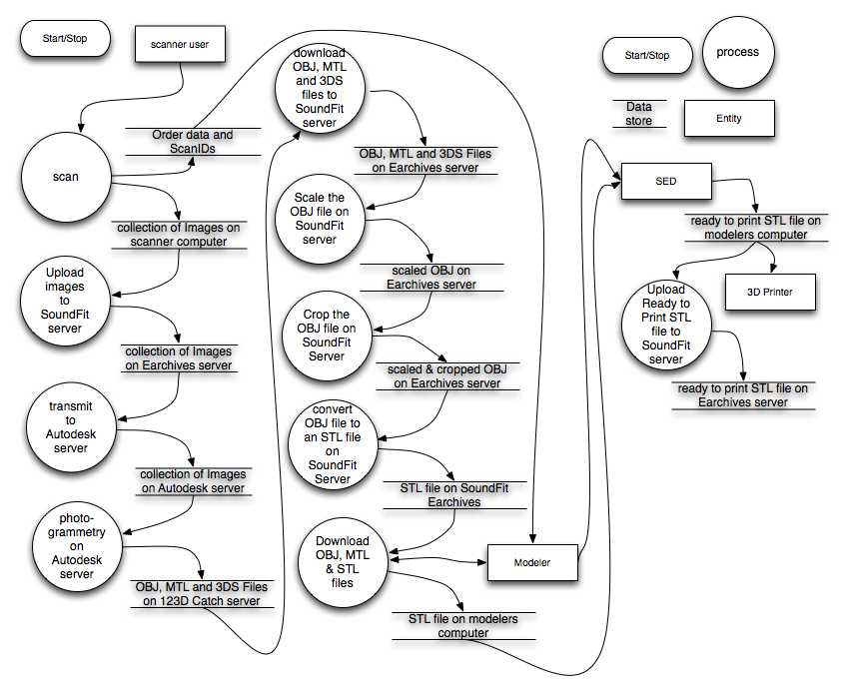
Figure 2: Earchive State diagram

SCANNER TRANSMISSION (SENDING) STATES:
The major transmission states are shown in Figure 3. This state diagram always begins, and ends, at the Checking Queue state. Not all transmission states have corresponding windows. For instance there is a Checking Queue / Wait loop, and neither of these states have – and the wait state has no window. The corresponding window for the Checking Queue / Wait loop is SEND state (also known as Idle).

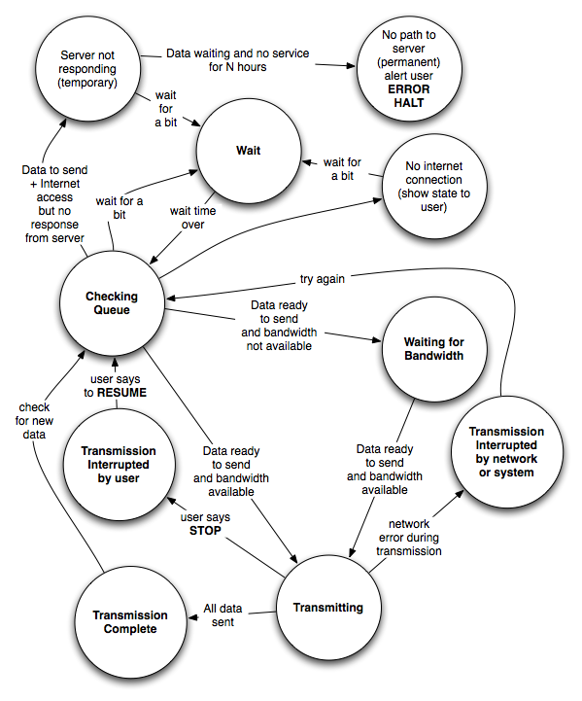
Figure 3: Transmission State diagram

EARCHIVES ENTITY RELATIONSHIP DIAGRAM:
The Entity Relations Diagram in Figure 4 shows the major stakeholders (Scanner User, Manufacturer, Modeler), and the major Data structures (Order, Scan, Image Set, Image, Scanner), and the attributes associated with each entity:

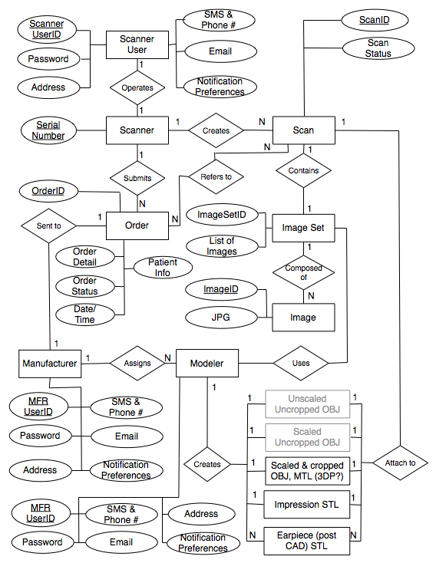

Figure 4: Entity Relations diagram

EARCHIVES OBJECT UML DIAGRAM:
The Class and Object UML Diagram in Figure 5 shows the data structures in terms of objects with attributes and methods.

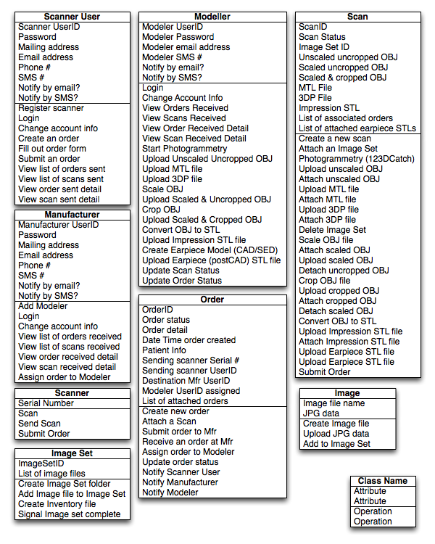

Figure 5: Class and Object Model

2.4 General Constraints
This subsection of the UXDD should provide a general description of any other items that will
limit the developer’s options for designing the system. (See the IEEE Guide to SRS for a partial list of possible general constraints).

2.5 Assumptions and Dependencies
This subsection of the UXDD should list each of the factors that affect the requirements stated in the UXDD. These factors are not design constraints on the software but are, rather, any changes to them that can affect the requirements in the UXDD. For example, an assumption might be that a specific operating system will be available on the hardware designated for the software product. If, in fact, the operating system is not available, the UXDD would then have to change accordingly.

3. Specific Requirements
This will be the largest and most important section of the UXDD. The customer requirements will be embodied within Section 2, but this section will give the D-requirements that are used to guide the project’s software design, implementation, and testing.

Each requirement in this section should be:

- Correct
- Traceable (both forward and backward to prior/future artifacts)
- Unambiguous
- Verifiable (i.e., testable)
- Prioritized (with respect to importance and/or stability)
- Complete
- Consistent
- Uniquely identifiable (usually via numbering like 3.4.5.6)

Attention should be paid to the carefully organize the requirements presented in this section so that they may easily accessed and understood. Furthermore, this UXDD is not the software design document; therefore one should avoid the tendency to over-constrain the implementation of the software project within this UXDD.

3.1 External Interface Requirements

3.1.1 Data Transfer Interfaces
Uploads
Downloads

Uploads and Downloads may use SFTP or HTTP.

3.1.2 Database Query Interfaces
Getting data values from the data tables
Setting data values in the data tables.

User Interfaces illustrated below allow scanner users to view lists of orders and scans they submitted, detail records for individual orders or scans, as well as to view their account details. The users may change some of those account details (e.g. password).

3.1.3 Data Viewing

3.14 Data Formats
OBJ
STL
Order & Tracking Data

3.2 Graphical Design Guidelines
We are waiting for a style guide from our artist. It isn’t present at this time, so for now the design appearance in the Wix demo is our style guide.

When the style guide is complete it should include the following definitions.

Appearance:

- Text Fonts, Styles and Colors for:
  - SoundFit Logo:
  - SugarCube Logo:
  - PCL Logo:
  - Titles:
  - Headings:
  - Body text:
  - Buttons:
  - Labels:
  - Text Fields
  - Hot links (clickable text)
- Graphic objects: Colors, line styles, line widths, margins, borders, backgrounds, foregrounds, gradients, shadows for:
  - SoundFit Logo
  - SugarCube Logo
  - PCL Logo
  - Photo and Video Image Displays
  - Status Information areas
  - Error Information areas
  - Warning Message areas
  - Window backgrounds and styles
  - Scroll bars
  - Buttons
    - Disabled
    - Default selection
    - hover actions
    - corner styles
    - gradients
  - status icons
    - corner styles
    - gradients
  - thumbnail images
  - progress indicators (spinners and grow bars)
  - tables and grids

Layouts, Location and Sizes:
Header
Footer
Image Area
Information Area
Status icons
thumbnails
Control buttons
Close, Maximize and Minimize buttons
Menus
Form elements

4. Proposed User Experience for initial 2 Alpha testers (and maybe 8 more Beta customers).
The following outline describes the experience the scanner user should expect, the experience that modeler should expect, as well as the processes that are happening on the server.

Expected SCANNER USER experience for scanning Left and Right impressions and sending them to PCL:

- Scanner User Clicks the Scan button.
  - Scanner generates a unique ScanID (from scanner serial number and DateTime stamp)
  - Scan runs to completion in about a minute.
  - Scanner UI displays the ScanID in a button that says "Copy ScanID to clipboard: <ScanID>".
  - User clicks button, copying ScanID into their copy & paste buffer.
  - 2nd window appears saying "SENDING ScanID: <ScanID>.
    - Sending dialog box displays sending progress with progress bar, until done.
    - Then it closes automatically.
- User opens an online order form for PCL in a browser.
  - Order form configures itself for a new order and assigns a unique OrderID.
  - Finds text field called "Left ScanID".
  - User hits CNTL-V to paste ScanID into the field.
- User switches back to the Scanner UI window.
  - Scanner User Clicks the Scan button again.
  - Scanner generates a new unique ScanID (from scanner serial number and new DateTime stamp)
  - Scan runs to completion in about a minute.
  - Scanner UI displays the new ScanID in a button that says "Copy ScanID to clipboard: <newScanID>".
  - User clicks button, copying new ScanID into their copy & paste buffer.
  - 2nd window appears saying "SENDING ScanID: <newScanID>.
    - Sending dialog box displays sending progress with progress bar, until done.
    - Then it closes automatically.
- User switches to the online order form in a browser.
  - Finds text field called "Right ScanID".
  - User hits CNTL-V to paste 2nd ScanID into the field.
  - User completes the rest of the order form.
  - User Clicks the "Submit" Button.
  - Web page displays "OrderID: <OrderID> Submitted.".
  - Order page resets itself for creating a new order.
- User is done with scanning, but if they try to close scan UI while transmission windows are active, The scanner window tries to avoid being dismissed and tells them "Don't shut me down, I am still sending scans...."

Expected MODELER USER experience for scanning Left and Right impressions and sending them to PCL:

The Modeler (e.g. Ron or Monte) is someone at the Manufacturer (e.g. PCL) who receives the order.

- Orders are received by the Modeler via the SugarCube.Modeller@shopPCL.com email account.
  - The email contains an SugarCube orderID, and a list of the 0, 1, or 2 scanIDs attached to the order.
  - The rest of the email is the manufacturer’s online order form (in HTML form, so they will want to ready with an HTML capable email client).
  - The orderID is hot linked to http://earchives.soundfit.me/modeler.php?order=<orderID>
  - Opening this hot link shows the current order status webpage for that ordered, and includes a list of all the scanIDs associated with that order, and their current statuses.
  - Each scanID is hot linked to http://earchives.soundfit.me/modeler.php?scan=<scanID>
  - Opening this hot link shows the current scan status webpage for each corresponding scanID.
- Scans might still be uploading and may not be ready for processing at the time the order, and email is received. This will let a Modeler know that an order is coming. (And if they don’t see scans uploaded shortly thereafter the modeler can contact the scanner user to verify that there isn’t a transmission problem.
- A 2nd email will be sent whenever a scan reaches the "STL Ready" state. This will be the trigger to the Modeler that they can start work.
  - This email will contain a hot link to the scan status page for that ScanID.
  - Opening the hot linked page allows the Modeler to see the scan status, and depending on the status to download various files for local processing.
    - If the scan is in "Receiving Scan files" status, nothing more can be done until this is complete.
    - If the scan is in "Sending Scans to Photogrammetry" status, the ScanID folder of images can be downloaded as a zip file.
    - If the scan is in "Scaling" status, the OBJ file from Autodesk can be downloaded.
    - If the scan is in "Cropping" the rescaled OBJ file can be downloaded
    - If the scan is in "Converting to STL" the cropped OBJ file can be downloaded.
    - If the scan is in "STL Ready" the STL file can be downloaded.
  - In our initial release the photogrammetry, scaling, cropping and converting processes may not be fully automated.
    - For each program that isn't yet automated, the Scaling, Cropping and Converting programs listed above will send the modeler an email each time a file is ready for the next step in scaling, cropping or converting and stop.
    - The Modeler can then download the corresponding file, run the necessary manual program to create the result file, and then the modeler can upload the file, and start the next step.
    - As each of the steps is automated, that download/manual step/upload piece will be eliminated and the process will become increasingly automated. Ultimately, the modeler won't need to do anything until they are emailed that a scan is in the STL Ready state.
  - The Modeler can also upload PostSED STL files for specific earpiece designs. These are attached to the Scan record and can be retrieved at a later time to re-manufacture an earpiece.
  - The Modeler can add update Manufacturing Statuses.
  - The Modeler can restart any programs where processing has stalled.

Automated Backend server processes (unattended):

On the backend, this is what is happening on the SoundFit (Earchives) server:

- Each scan upload request is received as it comes in, and processed as follows.
  - A folder with name that contains the scanID is created.
  - A new record, with ScanID = <scanID> is added to the Earchives MySQL database.
  - The status field for the record is set to: Status = "Receiving Scan files."
  - Image files are uploaded into the folder.
  - When the last scan image is uploaded a folder file inventory list file, X_inventory.xml, is uploaded.
  - The X_inventory.xml file lists all the file names of the image files in the folder,
  - The X_inventory.xml file is sent to a PHP program, photogrammetry.php, which submits the files to AutoDesk server using the REST protocol, the submission is given a model name containing the <ScanID>.
  - The photogrammetry.php also changes the status field for this scanID to: "Sending Scans to Photogrammetry".
  - The server sends a confirmation message to the client side program, telling it that the transmission is complete (so the scanner user's transmission window can be automatically dismissed).
- Each order submitted runs an PHP program, orderEmail.php.
  - This PHP program generates an orderID.
  - This PHP program creates an file containing an email file, with MimeType: HTML, whose contents is the current source of the web page, and is addressed to SugarCube.Modeller@shopPCL.com, with Subject: "SugarCube Order: <OrderID>"
  - This PHP program submits the email to the email.SoundFit.me SMTP server on Dreamhost,
  - This PHP program tells the user's browser to display: "OrderID: <OrderID> Submitted.".
  - This PHP program reloads the order page (resetting values).
  - The Earchives MySQL database is opened
    - A new record is created in the Orders table.
    - The new record has the OrderID field set = <orderID>.
    - The manufacturerID field is set to the manufacturerID for this manufacturer. For this release this field is always "PCL".
    - Each scanID is appended to the end of the ScanIDList field.
    - Each scanID record in the Scans Table is opened.
      - The orderID is appended to the orderIDList field. (This enables both tables to be searched and back linked to each other).
- Whenever Autodesk completes creating the model, it should send an email to photogrammetry.models@SoundFit.Me.
  - SoundFit's email server is set to deliver emails to this address to a program: PhotogrammetryEmailParser.exe.
  - PhotogrammetryEmailParser.exe reads the email from Autodesk, and extracts out the following items:
    - The ScanID of the submitted model.
    - The URL of the OBJ file.
    - The URL of the 3DP file.
    - The URL of the MTL file.
  - For each OBJ, 3DP and MTL file URL provided, the corresponding file is accessed and downloaded into the Scan folder.
  - The scaling program, Rescale.exe is launched, passing the scanID and the OBJ filename:
    - Rescale.exe <scanID> <OBJfilename> scaled-<scanID>.OBJ &
  - The <scanID> record in the Earchives MySQL database is retrieved.
  - The Status field in the record is set to Status = "Scaling".
- When the Rescale.exe program completes scaling:
  - The rescaled OBJ file should be written into a new file named: scaled-<scanID>.OBJ.
  - The cropping program is spawned :
    - Crop.exe <scanID> <OBJfilename> cropped-<scanID>.OBJ &
  - The <scanID> record in the Earchives MySQL database is retrieved.
  - The Status field in the record is set to Status = "Cropping".
  - Rescale.exe terminates.
- When the Crop.exe program completes cropping:
  - The cropped OBJ file should be written into a new file named: cropped-<scanID>.OBJ.
  - The OBJ to STL conversion program is spawned :
    - OBJ2STL.exe <scanID> cropped-<scanID>.OBJ <scanID>.STL &
  - The <scanID> record in the Earchives MySQL database is retrieved.
  - The Status field in the record is set to Status = "Converting to STL".
  - Crop.exe terminates.
- When the OBJ2STL.exe program completes writing the STL file:
  - The <scanID> record in the Earchives MySQL database is retrieved.
  - The Status field in the record is set to Status = "STL Ready".
  - An email file is generated and is sent to "SugarCube.Modeller@shopPCL.com" with "Subject: SugarCube Scan: <ScanID> Ready".
  - OBJ2STL.exe terminates.
- Whenever the modeler uploads a CAD processed (finished earpiece) STL file.
  - Once the modeler reads the ScanID Ready model, they can go to their web interface and download a copy of the STL file from the Earchives server into their local computer.
  - Once the modeler has a local copy, they can run SED or 3Shape or other CAD program to create a new STL file on their local machine.
  - Once the modeler has created a new STL file, they can upload it to the Earchive server through the web based Modeler GUI.
  - Uploaded processed STL files are added to the scan directory, but given a unique name based on the moceler submitting and time stamp.
    - Uploaded processed STL files are added to the ProcessedSTLFiles field in the ScanID table of the Earchives MySQL Database.
- Modelers can view the Order Table of all orders sent to their manufacturing ID (e.g. "PCL").
  - They can download any scanID for attached to the Order record.
  - They can change the Manufacturer's Status Field from "Submitted" to "In Manufacturing" or "Shipped", and add an optional package tracking ID.
- Modelers can view the list of ScanIDs sent in their orders.
  - They can download any scan files associated with any scanID attached to the Order record.
- Every day we run a cleanup program that automatically examines all files
  - If there are any image files that are more than one day old, for which there is no X_inventory.XML file in the folder, will be flagged, so that PCL can contact the sender and tell them, that a transmission in progress was not completed.
  - Scan image files more than 30 days old, for which there is an STL file are deleted.
  - Unscaled OBJ files more than 30 days old, for which there is a Scaled OBJ file are deleted
  - Scaled OBJs more than 30 days old, for which there is a Scaled and Cropped OBJ are deleted.
  - Cropped

5. Screen shots:

These screen shots show the different pages in the GUI, and current images, font, colors, layouts, etc. These are subject to change after our artist writes the style guide and selects images.

Please see the online mockup pages accessible through the index page at: http://sc6921.wix.com/sugarcube - !modeler/c6xu, for the latest revisions.

Account Info Pages
Every user of the Earchives system must have a valid user account, with a UserID and Password.
Users can login using either their UserID or Email address, plus their password.
Users can modify their password, and notification information and preferences.

Earchives Login
To be able to access the Earchives database users must log in. They can generally only see orders and scans they sent (if they are a scanner user) or which were sent to them (if they are a manufacturer). Modelers working for manufacturers can view those scans that were assigned to them for processing.

Edit User Account Info
Once Users log in, they should be able to change a password, change their Name, email, phone and SMS text numbers, as well as change their default notification preferences.

Scanner users should be able to register their scanner’s serial number. They can also see and change their billing plan.

Manufacturers need to be able to tell Earchives where the Order URL is because the Scanner User Interface encapsulates the manufacturer’s order forms within our Scanner Controls. We also need a URL for their logo since we will use that to allow users to choose which manufacturer to send their models to.

File Uploads
During our initial release modelers will have to manually upload scaled OBJ files, cropped OBJ files, and converted STL files. They may also voluntarily upload a post CAD earpiece STL.

After scaling, cropping, and converting are automated, Modelers will only need to upload CAD earpiece STLs.

Orders

View Orders by Sender
Senders can use this list view to see the status of all orders they have sent. It is in inverse chronological order so their most recent orders will be at the top.

They can also change their notification preferences on whether (and how) to be notified if an order changes state.

View Orders by Manufacturer
Manufacturers will use this list to see any new orders that they need to work on, and what the order status is for each order already in progress. Clicking on the hotlinks also allows the Modeler to get to an Order detail or Scan Detail page from which they can do an upload.

They can also indicate whether they want an email or text sent anytime the record changes state.

View Order Details
Scanner Users and Manufacturers alike can consult the data in the Order Detail record.
Note that the patient name and email has been extracted from the order form, and may not always be present.

Also note that the Order detail record knows about any scans that were attached, and any CAD models that were attached. Clicking these hot links allows you to go directly to the Scan detail record, or to the CAD detail record, from which you can download these files.

Scans & 3D Models

View Scans by Sender
Senders can view all the scans they sent. Since they get charged if they exceed the maximum number of free scans per month, we tell them how many they have already used in their Month to date, and what their plan allows.

The channel partner (typically a manufacturer) who is renting the SugarCube to the audiologist can also view this view and see whether to bill the scanner user for overage use.

View Scans by Manufacturer
Manufacturers can view all the scans sent to them. These are shown in reverse chronological order so that the most recent scans (likely orders in progress) are at the top.

View Scan Details (for Senders)
During our initial release, we expect the Modelers to have to manually transform various files. But there is no reason to expose these intermediate steps to Senders. Senders will see a page like this one, except the part that says Manufacturers Only will be hidden.

Once we have automated these intermediate steps, the View Scan Details for Manufacturers will be the same at for Senders, with the added capability of the area shown in the box labeled Manufacturers only, where manufacturers can upload and attach CAD files and add notes to be shared with the Sender and later users of this record.

View Scan Details (for Manufacturers)
In our initial release we don’t expect the Photogrammetry, Scaling, Cropping and Converting steps to be fully automated. Until they are, we need to provide a way for Modelers to download each intermediate file, run the proper transformation process and upload the resulting file back up to the server.

Once these steps become automatic, this page will be replaced with the View Scan Details (for Senders) page, with the For Manufacturers section visible and enabled.

View Post SED CAD Models
After we deliver to the Modeler a 3D impression model, they can use a CAD program such as Secret Ear Designer to create a 3D earpiece model that can be printed by a 3D printer.

We allow Modelers to upload any such files they create and attach them to the impression scan record. This page allows users to search for these models and download any already on file:

